-Command prompt used to be called command window. In Linux and OSX it is called terminal window or shell. Many programmers simply call it command line.

-Command line interpreter (CLI) of MS DOS is command.com. It has been replaced by cmd (after its command name) or cmd.exe (after its executable file name), also known as command prompt. cmd is the CLI of Windows NT.

<https://en.wikipedia.org/wiki/COMMAND.COM>

<https://en.wikipedia.org/wiki/Cmd.exe>

-Scripting language of ms-dos is batch. It consists of a series of commands to be executed by the CLI. The term “batch” is from batch processing, meaning “non-interactive execution”.  
  
When a batch file is run, the shell program (CLI) such as COMMAND.COM or cmd.exe reads the file and executes its commands, normally line-by-line.   
  
The filename extension .bat is used in DOS and Windows. Windows NT and OS/2 added .cmd.

-To **change drive** use D: or C:  
  
 To **change directory** use “cd address (or subfolder name)”. To navigate up one directory level use “cd ..”. To navigate into the root directory use “cd /”.  
  
 To **change default directory** youright click cmd icon and edit “Start in:” from properties.  
  
**-Seeing files and folders in directory: Using dir alone shows us the folders and files in the current directory.**

**dir name looks for a folder or file in current directory.**

**dir name /s looks for a folder or file in current directory and all subdirectories.**

**dir Java Notes.docx /s searches for both the folder “Java” and file “Notes.docx” at the same time. So you can look for multiple files and folders at the same time. If you want to search for a file or a folder with space in its name, use quotes.**

**-Creating a folder md folderName  
  
-Creating a file: touch readme.txt**

**-Deleting a file/folder:  
  
 del abc.txt :: Deleting a file  
  
 rd folderName :: Deleting a folder**

**-Renaming a file/folder: Rename the first one to second one.**

**ren arithmetic.R arithmetic.r**

**ren Module1 Module2  
  
-Executing a program  
  
 “run/start program_name” (first you need to go to the address).   
  
 If you only type the program_name, it will execute if it is an executable file such as .exe.**

**Classpath:** The default value of the class path is ".", meaning that only the current directory is searched.

Clear classpath: “set CLASSPATH = .” or “set CLASSPATH = ”

Set classpath: “set CLASSPATH = path1;path2...”

Print classpath: “echo %CLASSPATH%”

You have two choices. You can set classpath manually before you run your programs then run the programs from bat file. Or you make all your programs reset and set class path in the bat file.

**java InitArray 5 0 4 :: manual and static**

**pause**

set CLASSPATH = C:\Users\Michael\Desktop :: automatic and static

java InitArray 5 0 4

pause

You can make it so your program works no matter where the .class file is.

set CLASSPATH = %~dp0 :: automatic and dynamic

java InitArray 5 0 4

pause

%0 gives the adress of the batch file

%~dp0 gives the address of the folder of the batch file

<https://stackoverflow.com/questions/17063947/get-current-batchfile-directory>

-Getting username

echo %userprofile%

**-Copy file/folder**

copy /y %~f0 "%USERPROFILE%\%AppData%\Roaming\Microsoft\Windows\Start Menu\Programs\Startup

%0 references argument 0, the name of the batch file.  
%~f0 causes %0 to be expanded to a fully-qualified path name.

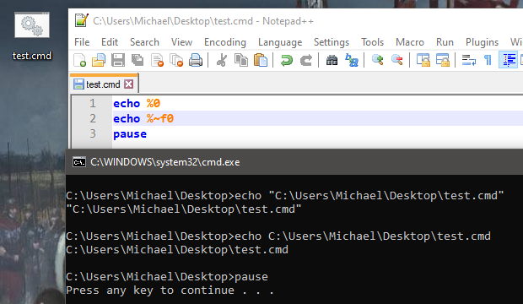

copy "path of file you want to copy" "path of the directory where you want it copied"

Copy contents of a folder to another folder

xcopy C:\Users\Michael\Desktop\a C:\Users\Michael\Desktop\b

Copy folder itself and contents of the folder to another folder

xcopy /e C:\Users\Michael\Desktop\a C:\Users\Michael\Desktop\b\a

**-Move folder**

move C:\Users\Michael\Desktop\a C:\Users\Michael\Desktop\b